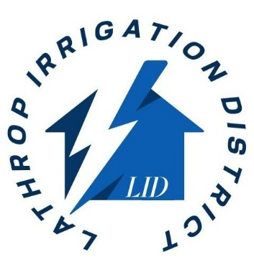

THE LID BOARD OF DIRECTORS MEETING SCHEDULED FOR 12/10/2025 HAS BEEN CANCELLED

